DRAFT REPORT

An Evaluation of
Southwest Florida Basin Rule BMP Efficiencies

BY
Marty Wanielista
August 31, 2006

SECTION 1: INTRODUCTION

The draft rule defines a menu of BMPs that can achieve pollutant removal using various stormwater management methods. Furthermore, it is understood that the District drafted this Basin Rule to reduce pollutant loading, primarily for nutrients, in the Southwest Florida region.

Objective of this Review

The objective of this report is to provide a review of the Draft Rule and information regarding the efficiency of nutrient removal for the BMPs listed in the Draft Rule. It is understood that a goal of the Rule is to improve stormwater management with removal of phosphorus and nitrogen compounds.

Organization of the Report

Information on estimated nutrient removal efficiency for some of the BMPs in the Draft Rule is presented. Other BMPs that are not listed in the current Draft Rule, but are applicable to the Rule, are also presented to assist in providing needed valuable options. There is an emphasis on information available in the State of Florida and in South Florida in particular. However, there is significant information on an international scale that is included in the reference section of this report. It is understood and verified that there are a lack of appropriate concentration data available for some of the proposed BMPs. Nevertheless, local rainfall and performance data are used to estimate removal efficiencies for those BMPs without appropriate design volume criteria. Recommendations on BMP design sizes are made that achieve a given mass removal efficiency.

Constraints or Limitations

The review was limited to the Draft Rule language which is shown in Appendix A. Additionally it is understood that the area for BMP application is the Southwest Florida Basin whose boundary is defined in the Draft Rule and thus defines rainfall conditions. The area further limits the application of the BMPs based on soil and land use conditions.

The Draft Rule requires applicants to implement additional water quality BMPs that are not specifically included in the current Basis of Review. A “menu” of BMPs has been developed and is included in the Draft Rule. The applicant is required to implement a certain number of BMPs from this list. The comments received as a result of the public workshops identified concerns that the BMPs needed to be quantified so that the number of BMPs required is not an arbitrary number. Thus within this report, available information is presented so as to quantify the effectiveness of the listed BMPs so that the Rule can be implemented with specific design criteria.

It is also understood that the Draft Rule requires the BMPs to be in addition to the existing rules and thus it is expected that improvement in the containment of pollutants will result.

With long detention and biological response times of receiving waters in the District, it is more likely that mass loadings over long periods of time will have a more significant effect on water quality as well as the visual appearance of the waters. Furthermore, hydrologic design volumes based on the frequency distribution of rainfall can be used with runoff volumes to estimate the size of some stormwater BMP systems. The rainfall used for design is related to the percent mass associated with each and every storm event of less than or equal to design volume. Thus the efficiencies are recognized as variable with rainfall and runoff volume and average annual efficiencies can be estimated.

There are many quantification methods, procedures, and equations that are applicable especially those that predict runoff measures. Within this report, some are used, but the reader is encouraged to use those which are best suited to the watershed under investigation or use those as specified by the reviewing agency or regulations.

For this review, an effort to identify nutrient removal efficiencies for each BMP was made. For some BMPs, data are available with a high level of confidence in their use. However, for other BMPs, there are not sufficient support data. As an example, in some publications, the efficiencies are not referenced as to the basis (concentration or mass) nor referenced to other important measures of the watershed and storm event. Nevertheless, some removal efficiencies are referenced as concentration or mass reduction over a specific time period (yearly is most frequently used) or on an event basis.

Finally, the intent is a review of the current Draft Rule language and not to complete a design manual or guide for stormwater methods or treatment trains for use in the Basin.

SECTION 2: METHODOLOGIES

Introduction

The Southwest Basins of the South Florida Water Management District are distinctive because of the climatic, soil, and ground cover conditions of the area. The natural area is part of the ground cover which affects the quality and quantity of stormwater discharges. There are many reasons to practice stormwater management. Flood control was the original reason, and remains one of the top priorities. However, the natural environment does receive long term damage when excessive stormwater quantities and pollution in stormwater are allowed to discharge untreated to the surface waters within the Basins.

The pollution within the runoff waters have resulted in a series of events that are either aesthetically unacceptable (algae blooms) or ones that destroy our environments (sea grass loss and erosion as examples). Thus National, State, and regional based programs have been implemented to reduce the mass discharges of pollutants into the surface and ground waters of the Southwest Basins. This means that stormwater must be managed to reduce the pollutant discharge mass. Add to these reasons problems related to salt water intrusion and land vegetation loss. Keeping the stormwater on the land as in the natural condition, will also recharge the shallow aquifers and conserve surface vegetation while helping to reduce salt water intrusion.

Water supply is another reason, as fresh potable water is relatively inexpensive compared to treatment of salty water. Drainage or runoff of rain to receiving waters that enter the estuaries essentially removes that rain from economic recycling. Also, runoff waters low in salt can have a negative effect on the wildlife of the estuaries and the surrounding waters, thus reducing water sport and fishing activities, in additional to the potential loss of habitat. Habitat is the basis for the quality of life and the aesthetic appeal of the area.

The Draft Rule is a mechanism to accomplishing a stormwater management program that will help preserve the standard of living and the natural environments of the Southwest Basins. There are many benefits, both tangible and intangible.

Effectiveness of Stormwater Management

For pollution control, stormwater management methods and procedures should be based on expected performance levels. The expected level is measured by the balance maintained in the hydrologic cycle and the quantity of pollutants removed before the runoff waters enter into surface and ground waters. Human activities produce pollutants that can be controlled by product modifications (such as unleaded gas), use limitations (such as low phosphorous fertilizers), source controls (Table V-1, Group A of the Draft Rule), conveyance controls (Table V-1, Group B of the Draft Rule), and enhancements to the current stormwater treatment practices (Table V-1, Group C of the Draft Rule).

A literature search for the effectiveness of stormwater management methods was conducted to determine the extent and consistency of the data base. All the references used are listed in the Appendices to this report. Over 300 were reviewed. Some are only found on web sites, thus the list of web sites is also included. Effectiveness data for concentration and mass changes for the same stormwater management method were not consistent among the data bases. The most complete data base for Florida conditions was produced by Harper (2006, Chapter 4).

At the national level, there exists a larger data base that includes some of the Florida information and for different watershed conditions, like land slopes and soils (Winer, 2000, and http://www.bmpdatabase.org/). Both the Florida data and the National Data base indicate widely variable concentration differences. There are many reasons for differences, including the sampling procedures, number of samples, methods for analyses, watershed land use, watershed slopes and soils, and stormwater BMP design differences. The variability in rainfall for different areas also account for differences even if the same size or design for a BMP is used. However, the data indicate that most methods can be effective in pollutant reduction and the effectiveness is related to design sizing and operation. Thus the method of design sizing has to be related to local watershed and local rainfall conditions. Mass reduction data appear to be more accurate and reproducible primarily because volume is predicted more accurately than concentration provided there is accurate description of both the rainfall and the subsequent runoff. As an example of the variability in the concentration data, a review of the latest work by Harper (2006) and that previously by Wanielista and Yousef (1993) will illustrate the variability in the event based and the event mean concentration data. An illustration of the variability is shown in Table 1. Undeveloped land has TP and TN average concentrations of approximately 0.05 and 1.0 mg/L respectively.

TABLE 1. Example Variability of Stormwater Concentration Data (mg/L)

Event Sampling EMC (event mean concentration)
Median CV (SD/Mean)
TKN 0.01 – 4.5
Organic Nitrogen 0.01 – 16.0
NO3-N 0.01 – 1.5 0.736 0.83
SRP (OP4) 0.01 – 10.0 0.143 0.46
TP 0.10 – 125 0.383 0.69
Source: Wanielista and Yousef, 1993

Balancing the hydrologic budget comparing a land use change to pre condition natural areas appears to be one stormwater management goal that is gaining national as well as State-wide use for pollution control. Basically, the yearly flow volume is estimated for the pre and post conditions, and then the systems are sized relative to the reduction needed. Stormwater management methods that employ post = pre volume conditions are classified as off-line retention, on-line partial retention, and recycling ponds or those that also reuse stored water. The recycle of stored water reduces the volume of discharge. The water quality of the stored water is in general considered to be irrigation quality water; however, any additional concern over organisms in the stored water can be eliminated if the water is filtered through the ground before it is recycled. Green roofs also employ the water recycle concept for irrigation of the plants and provide for a solution in highly urbanized areas. In other areas where volume can not be reduced, concentration reduction methods, such as those associated with wet detention, chemical use, and filtration are being used.

Off-Line Retention Methods

Off-line retention uses the principles of infiltration, evaporation, and recycling to treat runoff waters up to a specific design volume and then accepts only a small fraction or no more water after the design volume is reached. Thus the runoff water is diverted to the off-line treatment system up to the design size and the remaining runoff waters are discharged. Example names of stormwater management methods that follow the principles for off-line retention are: roof top retention, rain gardens, infiltration basins, bio-retention areas, diversion ponds, exfiltration tanks, and native planted areas.

For infiltration of the diverted waters, the soils and water table depth must be able to accept the runoff volume. Effectiveness is measured as a percentage of the yearly runoff volume retained and is typically based on rainfall history for an area, the watershed conditions affecting runoff, and the infiltration rates. The time to infiltrate the runoff volume is important to recover the design volume before the next storm event. A histogram of the number of storm events for a specific volume is shown in Figure 1. The data indicate that for the Southwest Basins, about 75% of the rain events are less than one half inch and 88% are less than one inch. There are about 125 of these events per year.
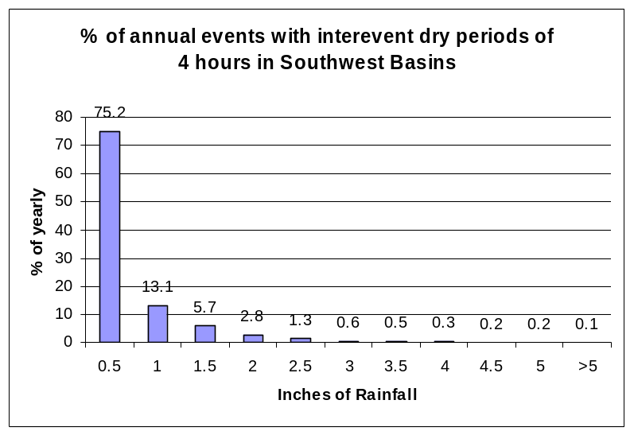
FIGURE 1. Southwest Basin Rainfall Histogram based on 38 years of Fort Myers Data

An off-line treatment system accumulates the design runoff from each and every event. The yearly volume associated with each design size is then the sum of all runoff up to that design event plus the design volume for every event greater that the design volume. Also, the larger volume storms carry with them a relatively larger cumulative volume of rainfall than the cumulative yearly volume associated with the smaller storms.
Example 1. Using Figure 1, the 0.5 inch design event rainfall accumulated 75% of the yearly rainfall events with an inter-event dry period of 4 hours, but only 52% of the yearly rainfall volume. While the 1.0 inch design event rainfall accumulated 88% of the storm events with 75% of the yearly rainfall volume. It must be also evident that the runoff volume is different from the rainfall volume and the effective impervious area is needed to transfer rainfall depth to runoff volume.

When designing the off-line systems, it is important to estimate the infiltration of the storage area and the volume of runoff expected from the watershed. During construction, the infiltration rates decrease because of compaction. For sandy Florida soils that are compacted to 92%, the infiltration rate decreases from about 10-12 inches per hour to about 2 inches per hour (Wanielista, 2006). Pitt (1999) also found normal urban development activities can compact sandy soils from 10-20 inches per hour to 1.8 inches/hour.

Design curves to aid in sizing off line retention systems can be developed using local rainfall data and for the inter event time for treatment. For infiltration systems this usually is the product of the limiting infiltration rate and the time for drainage. The percent of the yearly rainfall volume that can be captured multiplied by the effective impervious area at the design event volume is used to size the pond. Thus the rainfall history and the watershed conditions for the area are used and the design is specific for the area. The design curve using Ft. Myers rainfall data for off-line retention is shown in Figure 2. The curve is considered to be conservative in the estimate of efficiency for small watersheds because of the potential first flush effects. As a guide for the choice of an inter-event dry period, Harper (2006) reported 40 hours during the wet season for the region.
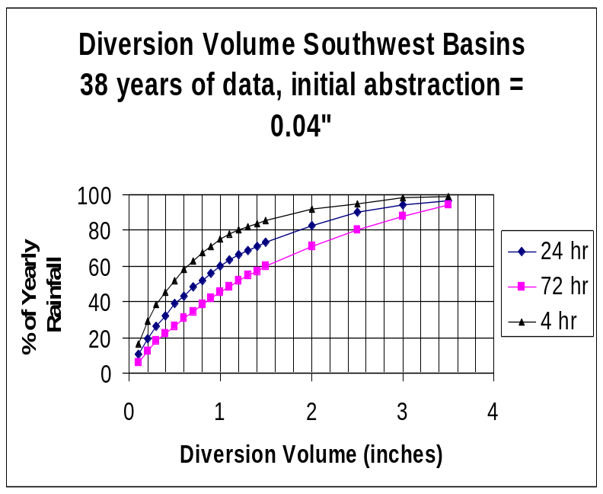

FIGURE 2. Off-Line Retention Design Curves for the Southwest Basins

Example 2. To demonstrate the use of Figure 2 for sizing an off-line system, consider 80% capture of runoff. The graph has three variables, thus one other is needed. A 40 hour inter-event dry is specified to drain the retention area during the wet season. The off-line system will capture the runoff from each and every event up a specified volume and at least the runoff of the specified volume for runoff of larger events. Next the effective impervious area is estimated from commonly used rainfall runoff procedures, such as, Curve Number or other modeling methods as found in the water management district manual of practice (Wanielista, 1997, Harper 2006). The effective area for this example is 6.4 acres at rainfalls between 1.5 and 2.5 inches. Thus the pond size from Figure 2 is read as 2.2 inches (80% and 40 hours) or 2.2*(6.40)/12 = 1.17 acre-feet (about 50,000 cubic feet).

Harper (2006) also present a methodology for calculating sizes based on rainfall and watershed conditions as shown in Figure 3. The size of the stormwater management system is calculated knowing the runoff for the pre and post condition and the difference between the two is an estimate of the efficiencies needed for a post = pre water management goal.

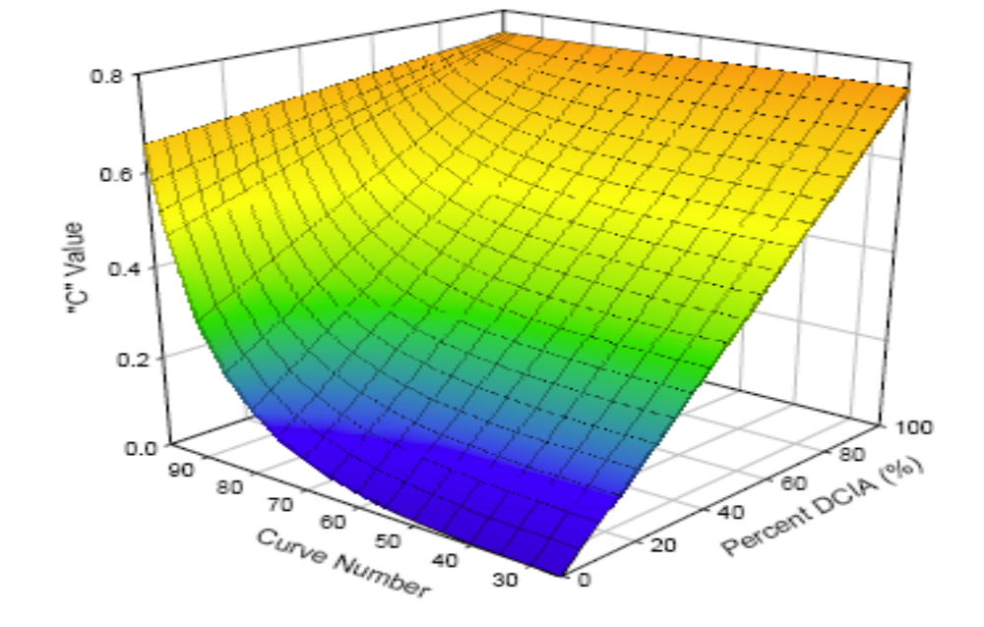
Source: Harper 2006
FIGURE 3. Annual Runoff Coefficient as a Function of Percent DCIA and CN

Example 3. To demonstrate the use of Figure 3, consider a post condition generating an annual runoff fraction of 0.4, and a pre condition annual runoff fraction of 0.08. To achieve a post = pre runoff volume, the % reduction must be 80%. However, the percent reduction may be higher or lower, depending on the watershed on-site water holding natural or design conditions, or a treatment train may be used for on-site volume reduction.

On-Line Retention Methods

The basic principle of operation is to have all runoff water enter the BMP. That which leaves is by infiltration, evaporation, recycling or surface discharge from the storage area. Water that is not recycled, evaporated, or infiltrated is otherwise discharged. Recycling is accomplished usually be pumping or infiltration.

The infiltration of water into the ground can be used to recharge wet lands. Pumping of the water from a horizontal well to deep well storage for recovery can also be called recycling. However, the typical use of the term is commonly used for irrigation of native plants, turf irrigation, car washing, food production, and other surface uses. Some other example names of stormwater management methods that follow the principles for designing on-line retention are: filter strips, berms, pervious pavement, vegetated swales, and green roofs. Green roofs are those that need irrigation to keep the plants healthy, and use a cistern that is on-line to store roof seepage water.

Stormwater recycling or reuse is defined as the continued and customary use of water for some implied benefit. The quality of the stored water meets the standard called irrigation quality water. When stored water is irrigated, there are two physical situations that must be examined, namely the recycled water does not return to the storage area or there is a consumptive use like in irrigation of turf and plants. The other physical situation is when some of the recycled water returns to the stored area like in the irrigation of green roofs.

Stormwater Recycling with No Return of the Recycled Water to the Storage Area

Irrigation usually replaces the use of potable water and thus there is a benefit in the savings of valuable potable water. In addition, stored storm water recycling is in general less expensive to deliver than potable water. There are examples of utilities set up across the State the have been either given a franchise or are operating to make a profit selling stormwater as a commodity. The other benefits to a community or a municipality are a reduction in cost of water supply, a balance of the area water budget, and a reduction of total pollutant mass.

The parameters for estimating the efficiencies of recycling systems are rainfall history and the watershed conditions. In addition, the rate of recycling or infiltration measured in volume terms must be either specified or estimated. The design variable of most concern is the volume of the pond. This is called the recycled volume, and is the volume frequently equated to the pollution control volume because it is similar in size. It is also drawn down for irrigation similar to the removal of the pollution control volume. It is recommended to use horizontal wells for irrigation. An example of the recycled volume for a recycled pond with the other controlling volumes in design is shown in Figure 3. The recycled volume is “stacked” on top of the permanent pool. The flood control operation is not compromised with this design as it is essentially the same as with any on-line wet detention pond. When using on-line systems for infiltration, the infiltration volume has to be estimated as is a function of the infiltration area and the rate.

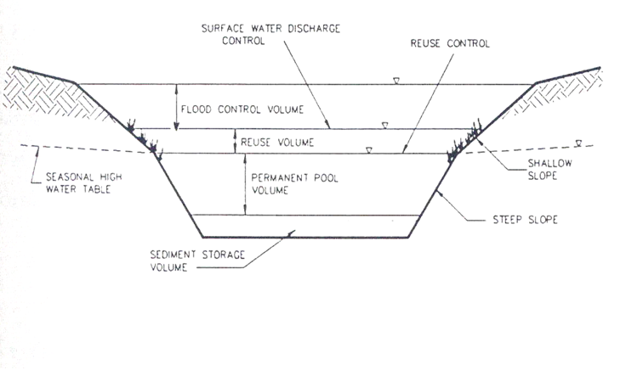
FIGURE 4. A Stormwater Reuse or Recycling Pond with Volume Design Parameters

The design graphs for recycling where no recycled water is returned to storage are shown in Figure 5.

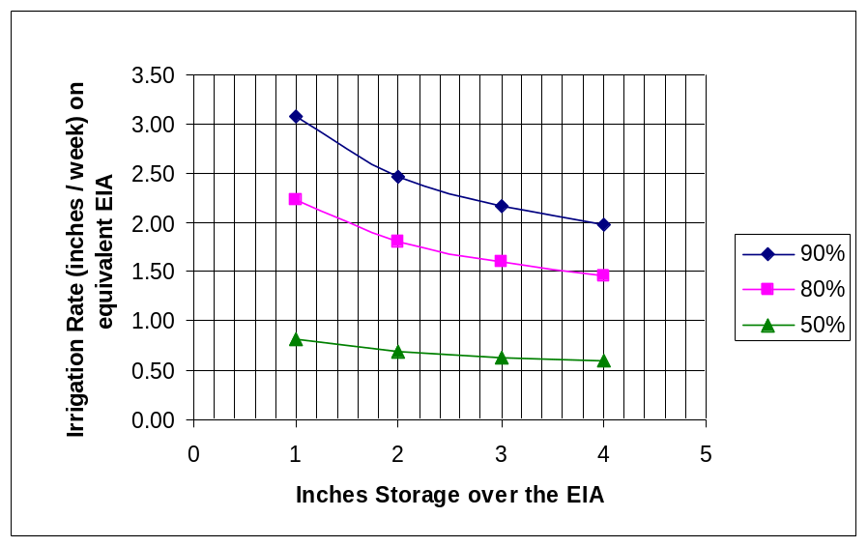

FIGURE 5. Recycle Efficiencies Volume Curves for Consumptive Irrigation in the Southwest Basins (Recycle Ponds)

Example 4. This will demonstrate the use of Figure 5 to specify the pond size and irrigation area. There are three variables in the graph, thus two of the three must be specified to calculate the other, making the use of the graph an iterative approach in some cases. Eighty percent efficiency is the target. Using 2 inches for the pond size from an effective impervious area of 6.4 acres, a recycled volume of 1.07 acre-feet inches is calculated for a recycled rate of 1.8 inches/week on the effective impervious area, or 11.5 acre inches per week. The irrigation rate on the average in some areas may not exceed 1.0 inch per week, thus the area for irrigation has to increase up to 11.5 acres.
Stormwater Recycling with Recycled Water Return to Cistern (Green Roofs)

A green roof with a cistern is an example of a stormwater method that is used to attenuate, evaporate, and lower the volume of discharge coming from a roof surface. The green roof will neutralize acid rain; and when used with a cistern, the cistern discharge will have less pollutant mass. The green roof itself is an additional insulation because it contains a drainage media, growth media, and vegetation. Light weight materials are used to support plants and reduce the cost of the structure. The roofs are gaining in popularity in the U.S. and have been used for over 60 years in other Countries. In the State of Florida, use of native plants is encouraged (www.stormwater.ucf.edu).

Green roofs and cisterns are known to also save money. Initial and repair costs of a conventional roof are higher over a 50 year period when compared to the initial investment and operation of a green roof. Green roof materials have been known to not need replacement for at least 50 years, while the re-surfacing of flat roof tops in Florida may occur as frequently as every 15 years. Life cycle cost with a 3% discount rate over 60 years showed a savings (Lee, 2004) with a green roof on a municipal building.

Roofs collect both dry and wet fallout similar to other watersheds and thus there is an accumulation of pollutants that are washed from the roofs during rainfall events. A sampling of average roof top nutrient concentration data in runoff is compared in Table 2 to other average concentration data from other land uses and gages. The roof top and gage data of Table 2 were adjacent to a grassy area. Note that for most comparisons, roof tops can be a relatively high percentage of the average concentration of other land uses.

TABLE 2. Conventional Roof Concentration Data Comparisons to Other Watersheds

Land Use TN (mg/L) TP (mg/L) Reference

Roof Tops 1.11 0.458 Wanielista & Hardin (2006)
Rainfall 0.62 Wanielista & Hulstein (2004)
Precipitation Gage 1.59 TN=NH₄+NO₃ USGS (2006)
Single Family 2.00 0.306 Harper (2006)
Commercial 1.07 0.290 Graves (2004)
Commercial (high) 2.40 0.345 Harper (2006)
Multi Family 2.32 0.520 Harper (2006)
Pasture 3.47 0.616 Harper (2006)
Highways 1.64 0.220 Harper (2006)

To control the mass of pollutants from a conventional roof, a green roof can be used. A cistern or surface pond is used with a green roof to store the water and then the stored water is recycled on the roof as a source of irrigation. Then the direct discharge to surface water is reduced. Wanielista and Hardin (2006) showed that a cistern designed to collect 5 inches of roof runoff from a green roof with pollution control media was able to remove at least 90% of the mass of Soluble Reactive Phosphorus and 98% of the mass of Nitrate Nitrogen. The size of the cistern is dependent on local rainfall conditions.

The volume of water discharging from a green roof can be estimated from the rainfall history, the rate of stored water recycled, and the roof (watershed) conditions. The roof watershed condition reported within assumes an 8 inch depth of green roof. Using the complete rainfall data record for the Fort Myers area and a 1 inch/week average irrigation rate, a graph was developed to document the cistern storage needed to provide irrigation water for the roof as related to the percent of the rainfall that is not discharged. It is assumed that a non green roof will discharge all of the rainfall, but in reality, at least 95% of the rainfall is discharged. Thus, the curve of Figure 6 is conservative in estimating % yearly retention.

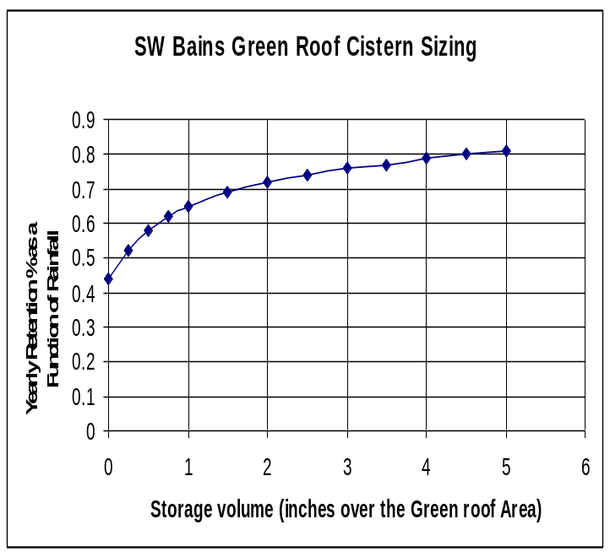

FIGURE 6. Southwest Basin Green Roof Sizing Curve

Example 5. Size a cistern for a green roof. The pre condition for the building site is a natural area with no directly connected impervious area and a composite curve number of about 83 which results in a pre condition yearly runoff volume of about 10.8 inches. The post condition treatment must be set for the yearly average rainfall of 54 inches. Based on the need to have the roof discharge at 10.8 inches, an 80% reduction is needed. Using a cistern that is sized at 2 inches will produce a 70% reduction in volume. The additional 10% will have to be discharged to another treatment train method, or more water stored on the roof for evaporation. The additional weight of water on the roof must then be considered. However, the cistern can be sized at 5 inches and the 80% target water removal will be achieved. Thus, this is an example of the quantification of the removal effectiveness of a BMP.

Pervious Concrete

This BMP is a special case of on-line retention. Pervious concrete is concrete with a minimum of fines, thus the concrete is permeable with a porosity of about 15-20%. Some mixes have a greater porosity but the weight bearing strength diminishes with increasing porosity. The pervious concrete reported within this report has a typical strength of about 2000 psi and is 8 inches thick. The specifications call for a mix applied using a certified contractor and must have a sub base preparation not exceeding a compaction of 92%, with a curb on the edges (Wanielista, et al, 2006a). The rate of infiltration through the concrete and in the soil, plus the porosities and depth to the water table determine the percent of the yearly runoff which infiltrates into the ground. The sub base materials in the unsaturated zone must be sandy and the rate of water movement in the water table and from the site must exceed at least 0.16 inches per hour. The containment of runoff using this system is about 99% of the average annual runoff.

Testing the infiltration rate is important to certify that the system is working as designed. Thus, during construction, a sampling infiltrometer is placed in the concrete. The infiltrometer is used during operation to measure the quantity of water entering into a section (pervious concrete and sub soils). A graph that aids in the quantification of the infiltration volume as a percent of yearly runoff is shown in Figure 7 for a sandy soil sub base. When the infiltration of the soil exceeds 1 inch per hour, and the water table during the seasonal high is 12 inches below the pavement bottom, then the concrete rate of infiltration must exceed 1.5 inches per hour to maintain 80% effectiveness for the average rainfall year.

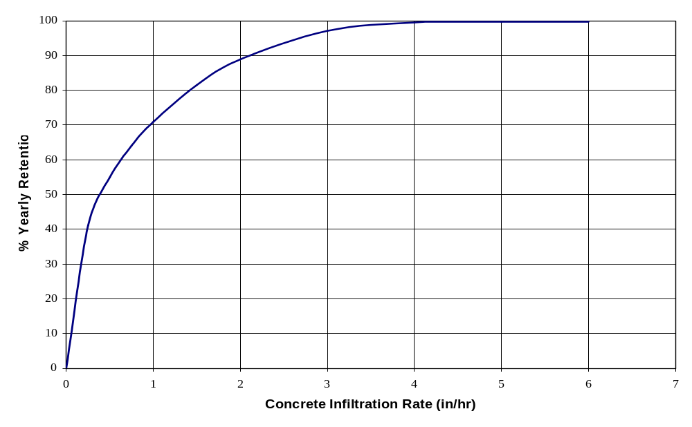
1.5”
Dc = 8”
Dwt = 12”
Fsoil = 1.0 in/hr
Faq = 0.16 in/hr
Figure 7. Performance of Pervious Concrete as a Function of Concrete Infiltration Rate
On-Line Infiltration Ponds

Common names for these systems are swales, berms, infiltration with overflow outlet, bio-retention, and on-line infiltration basins. Essentially they are shallow areas through which water both infiltrates and is transported. The infiltration rate and the groundwater table must be identified. The infiltration rates that are used to quantify the effectiveness are called limiting rates. After construction, these rates are significantly reduced; as for sandy soils compacted to 92%, the infiltration rate decreases from about 10-12 in/hr to about 2 in/hr (Wanielista, 2006), and Pitt (1999) reported normal urban development activities compact sandy soils from 10-20 in/hr to 1.8 in/hr.

A graph to aid in quantification of the removal effectiveness is shown in Figure 8. It is based on the rainfall data of Fort Myers and relates the size of the on-line infiltration method to the rate of infiltration for various runoff % removal curves. The watershed characteristics are incorporated into the effective impervious area calculations.

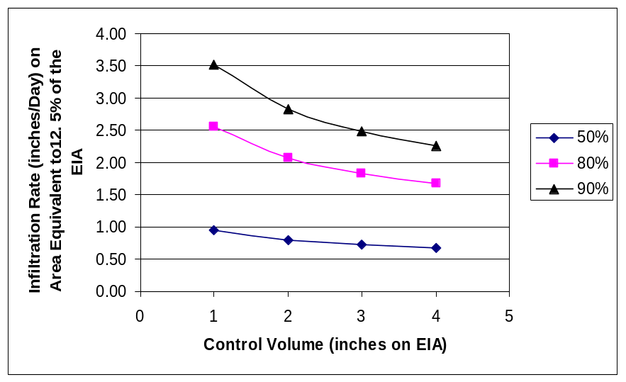

FIGURE 8. Infiltration Efficiency Volume Curves for On-Line Infiltration Methods in the Southwest Basins that have an Area equal to 12.5% of the EIA

Example 6. The limiting infiltration rate for a compacted area is 2 inches per hour and the effective impervious area is 6.4 acres (same as example 2). Size an on-line retention area (swale) to effectively achieve 80% removal. From Figure 8, the 2 inch per hour rate is sufficient to accomplish an 80% reduction if the pond size is 2 inches. The size of the infiltration volume is 1.07 acre feet (2x6.4/12), and the infiltration swale area is 0.80 acres (6.4x0.125), with an average depth of 16 inches. The depth can be lowered if the area increases. Note that the use of Figure 8 requires knowledge or specification of two of the three variables. The designer has the choice. If the limiting infiltration rate was 2.5 inches/hour, and 90% yearly efficiency was needed, the volume of the pond would increase to 3 inches over the effective impervious area (EIA). The limiting infiltration rate controls the average annual effectiveness. Also, the area as a percentage of the EIA can increase and thus decrease the average holding depth.
On-Line Detention Methods

Wet ponds are the most common type of on-line stormwater management BMP. They stay wet all year or most of the year depending on the rainfall in the dry season. They are designed with a permanent pool that provides the storage capacity to extend the residence time for stormwater. Concentration reductions are expected and Harper (2006) provides estimates for nitrogen and phosphorus concentration reductions, see Figure 9. Unfortunately, the reductions for most ponds constructed at 14 or 21 days residence are not sufficient to meet 80% or more reduction and the hydrologic cycle is not maintained.

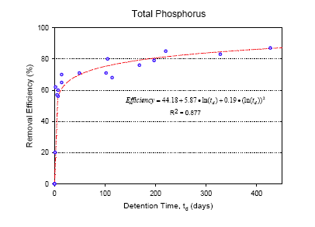

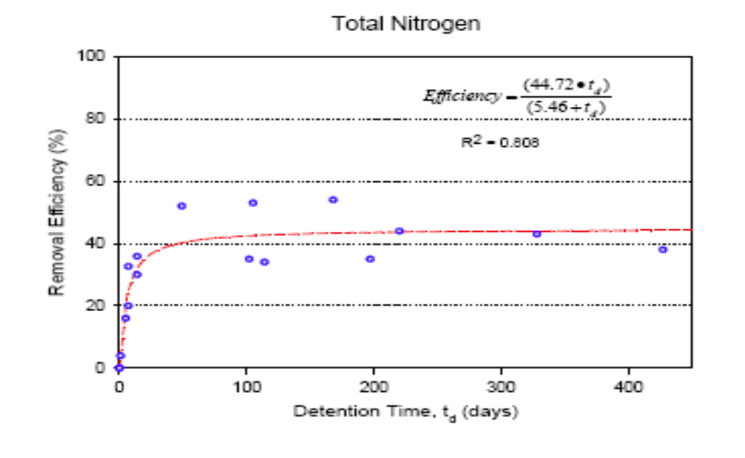
FIGURE 9. Phosphorus and Nitrogen Reduction in Wet Detention Ponds (Harper, 2006)

It is important to specify that the water table must be determined to set the control elevation for discharge from the pond and to hold the pollution control volume above the permanent pool. Ponds that flow continuously may produce more pollutant mass than that found in the inlet. Pollution control volumes have been specified by regulations. Residence times also have been specified in rules that are calculated primarily based on wet conditions.

Since the detention ponds do not achieve 80% mass reduction in and of themselves, additional BMPs in a treatment train are necessary to achieve higher removals. One other method to achieve higher mass efficiency of a wet detention pond is to convert the pollution control volume into a recycled volume and recycle a portion of the detained water.

Example 7. Nitrogen is the nutrient of concern for a water body receiving stormwater detained in a wet detention pond. Using the nitrogen graph of Figure 9, it is noted that only about 40% of the nitrogen can be removed using a wet pond. But an 80% reduction is needed. How much of the water must be recycled in order to attain an 80% reduction in nitrogen in the pond discharge? The recycled water will remove 100% of the nitrogen from the pond before discharge and the remaining fraction is assumed to discharge after a removal rate of 40%. The answer is the fraction of wet detention water recycled is 67% and the remaining 33% is discharges after it has achieved a 40% reduction in nitrogen. See Figure 10 for a schematic or flow chart of the calculations for this combination of treatment methods.

Enhanced
Control
67% effective
Structural
Control
40%
effective
67
33
13
20
100
Wet Detention Pond
Recycling
Ponds

Figure 10. Schematic of a Recycle Treatment Train for Nitrogen Removal with Recycling from a Detention Pond

Treatment Trains

It is most likely not possible in most development situations to have a single BMP that will meet pollution removal target levels for an entire watershed. Thus combinations of BMPs are used. One combination is to place BMPs in parallel with the cumulative sum of removals equal to the target removal. This can be as simple as multiple discharge locations from one land development or as complex as multiple discharges from different governments or entities. The overall efficiency is calculated knowing the mass removal for each individual method and then summing the mass removed by all methods and dividing by the input mass without treatment.

The more commonly used treatment train is when two or more BMPs are in series or the effluent of one BMP becomes the influent to another one. This is the more common definition of a treatment train, because one method follows another one. Example 7 is an illustration of a treatment train that includes two BMPs (recycling and wet detention) in series. Since wet detention is a common practice in the Southwest Basins, it is recommended to add recycling to attain higher efficiency. With these two BMPs, water and pollution control can be obtained and as a relatively inexpensive solution. Add to this a potable water savings (when irrigation quality water replaces potable water) and recycling from a wet detention pond is even more favored.

Example 8. Another example of a treatment train is green roofs followed by wet detention. The green roof is designed with a cistern to collect the roof seepage water from 1 inch of runoff from the green roof area, for a water capture efficiency of 67% (Figure 6). The remaining 33 percent is discharged into a wet detention pond with a water quality efficiency of 40% (Nitrogen). Thus the overall pollution control efficiency is (.67)(100) + (.33)(40) or 80% nitrogen mass removal. The water budget efficiency is 67%.

Source
Control
67% effective
Structural
Control
40%
effective
67
33
13
20
100
Wet Detention Pond
Green Roof
Figure 11. Schematic of a Green Roof and Wet Detention Pond Treatment Train for Nitrogen Removal

Example 9. A residential area is considering the use of swales to infiltrate and transport stormwater, but the infiltration rate of the swale after compaction is only 1 inch per hour. What average nitrogen removal efficiency can be expected? This is another example of a treatment train, but this time it is a swale followed by wet detention. The swale in example 6 has a limiting infiltration rate of only 1 inch per hour, yielding only 50% retention in water volume and nitrogen removal. A wet detention pond is then sized to treat the remaining 50%, for an overall nitrogen removal of 70%. To achieve an 80% target removal, the swale infiltration area would have to increase, if the infiltration rate did not change.

Transport
Control
50% effective
Structural
Control
40%
effective
50
50
20
30
100
Wet Detention Pond
Swale

Figure 12. Schematic of a Residential Swale and Wet Detention Pond Treatment Train for Nitrogen Removal (1 in/hour infiltration rate in swale)

Treatment trains can also be expected to achieve a higher than 80% removal efficiency. This higher efficiency is applied to some sensitive areas such as “Outstanding Florida Waters” and in some areas result from specific programs, such as, everglades protection. The removal rates may be targeted at 90% and in some cases, as high as 95%. If concentration limits are applied, these concentrations can be used to calculate removal efficiencies based on influent concentrations or loading rates.

An example of such a treatment train is a combination on source control, transport control and enhancements to structural methods. These combinations may be common in residential, industrial or commercial areas. The combination of each BMP may be in parallel or series. Example 10 illustrates a series combination to achieve 96% removal.
Example 10. The owners of a commercial area have decided to meet an OFW standard by using a combination of roof top storage (green roof and diversion plus pervious parking), and for transport a vegetated swale is specified with the final structural method a recycling pond. The efficiencies are listed in Figure 13. The effectiveness of the treatment train is calculated at 96%. Note that in this example the source control was all “lumped” into one efficiency estimate, and that effectiveness was the accumulation of parallel methods.

Source Control
50% effective
Transport
Control
60%
effective
Enhancement
Control
80%
effective
16
50
50
30
4
20
100
Vegetated
Swale
Roof Diversion & Pervious Pave PPaarea
Recycling
Ponds

Figure 13. Schematic of a Commercial Area Using Source Controls (green roofs and diversion of roof drains to rain gardens with pervious parking), Swales for Transport, and a Recycling Pond as a Treatment Train for Nitrogen Removal.

The treatment train concept depends on the estimates of the influent concentrations and quantities of stormwater. The above used and developed efficiencies are assumed to not change with concentration. Since concentration is so variable, this assumption may not be important as it affects performance. Nevertheless, the use of treatment trains provide for a more reliable operation and improved performance.

Chemical Treatment

Chemical treatment is the addition of a coagulant to stormwater that aids in the removal of pollutants. The two chemicals widely used for coagulation are aluminum compounds and polymers. The most widely used one for stormwater is alum and the most widely used one for erosion and sediment control is PAM, a polymer. The advantages of the use of chemicals are the relatively small space required for injection, monitoring, and storage, with the very high removal efficiencies. The flocculent that is formed is also inert and sediment toxicity is reduced.

The efficiency of alum to reduce pollutants in stormwater is shown in Table 3. The efficiency range is a function of the dosage of the chemical which is established at an optimal level. Thus the predicted removals do not have great variability. Note that the data in Table 3 are for concentration, and there is no reduction in the volume of stormwater. Nitrogen removal is less than 80%, so that some abstraction of the runoff volume using a treatment train combination within the watershed should be considered if the nitrogen target is 80%.

Table 3. Range of Efficiencies using Alum to Treat Stormwater

Parameter % Reduction

Particulate Nitrogen 88-96
Total Nitrogen 65-73
Dissolver Ortho P 96-98
Total Phosphorus 86-96
Total Suspended Solids 95-98

Source Harper (2006b)

It is noted that the effectiveness of this process is dependent on an understanding of the chemical reactions with the source water. The source stormwater must be examined and optimal dosages calculated for the highest possible removals.
SECTION 3: ANALYSES OF THE DRAFT RULE

Introduction

The Draft Rule is based on BMP choices from three groups. The groups are: source control, conveyance (pre-treatment), and stormwater management system enhancements. Each of the BMPs within the three groups is evaluated within this Section. This review is based on mass removal effectiveness estimates using Basin specific rainfall, soils and land use conditions.

Group A: Source Control

For the first two BMPs (reduced turf coverage and native plantings) under source control, the best construction option in terms of pollution control is to not disturb the area and continue with the native plants or with supplemental native plants. By not disturbing the soils, the infiltration capacity will be maintained, and the undisturbed watershed area will not have an increase in pollution load, assuming no additional fertilizer or other chemicals are used on the undisturbed area.

- Reduced Turf Coverage:
This option has the advantage of limiting fertilizer use and containing rainfall excess on the property comparable to the use of all turf. It has the added benefit of using less potable water for irrigation. To assess the water holding capacity, data must be provided on soil types, compaction, and water table depths. Compaction of the soil after construction will produce more runoff relative to the undisturbed condition. There are two conditions for estimating the mass removal effectiveness.
  - A design without specific additional holding capacity will produce greater runoff volumes and thus more pollutant mass relative to the natural area. Additional treatment has to be provided after the site alterations to accommodate the additional discharge.
  - A design with a specific holding capacity for diverted waters will achieve specific removal efficiency. Excess rainfall is contained above the natural holding capacity and let to flow from the area once a water storage depth has been obtained. Use Figure 2 for an off-line BMP effectiveness and Figure 8 for on-line BMP effectiveness estimate based on runoff quantity reduction. Concentration reductions can be estimated by comparing the completed design to the natural or pre existing condition.
- Native Landscape Plantings:
Similar to the previous reduced turf option, native landscaping has the advantage of limiting fertilizer use and containing rainfall excess on the property comparable to the use of all turf. It is assumed that new native plantings will be added. It is also assumed that in the post development condition, the soils remain un-compacted and the water table not altered or elevated over the pre development condition. If the soils are compacted, then suitable new soils or some form of un-compaction must be done. There are at least three possible conditions for estimating the mass removal effectiveness.
  - For an un-compacted soil and plant area, designs are completed without specific additional holding capacity. Thus for post equal pre conditions, there is no additional rainfall excess, discharge, and pollution load for that natural area. It is very important to mention that native plants may be introduced but without the use of construction equipment.
  - For compacted soil and plant areas, design with a specific holding capacity for diverted waters will achieve greater removal efficiency. This is an off-line retention option. Removal efficiencies can be estimated with the aid of Figure 2.
  - Design for a specific holding capacity for pass through waters called on-line retention. This is a design with detention. Excess rainfall is contained above the natural holding capacity and let to flow from the area once a specified water depth has been obtained. Removal efficiencies can be estimated with the aid of Figure 8.

- Stormwater Recycling: This BMP is the storage of stormwater runoff to be used for irrigation or other recycle options. The system operates such that the irrigation water is not returned to storage. There are a growing number of these systems in Florida with some having a dedicated Public Service Commission Service area. There are many benefits and those relating to stormwater management include the reduction of the volume of stormwater and the removal of pollutants. Removal efficiencies can be estimated with the aid of Figure 5.

- Rooftop Excess with Bioretention and Green Roofs: Building roof tops will be managed using either bio-retention or green roofs.
  - For Bio-retention, the capture of the first half inch is specified. If the capture is by off-line retention, then the efficiency can be estimated using Figure 2. For a pond with a recovery time of 24 hours, and ½ inch of each and every rain is captured, the yearly mass efficiency is estimated at 40% (see Figure 2). The use of on-line ponds is also possible and the efficiencies are estimated using Figure 5. Thus this BMP option for the Southwest Basins can be quantified.
  - For green roofs or those with natural vegetated covers and 8 inches of growing media, the efficiencies are estimated using Figure 6. A cistern is needed to control the discharge by holding the water to be recycled on the green roof or in the surrounding area. A cistern sized to hold the seepage from 2 inches of water over the roof area, will have a discharge less than 30% of the seepage (70% removal) relative to the runoff volume from conventional roofs. Efficiencies can be estimated using Figure 6.

- Rooftop Excess with Cisterns: For the purpose of estimating removal efficiencies, this BMP is considered to function as an on-line BMP, and Figure 5 can be used to estimate the average yearly removal of water.

- Pervious Pavement: Pervious concrete is the porous material evaluated for this BMP. There was no information available to the author to determine the effectiveness of other types of pervious pavements. Nevertheless, it should be clear from the research results to date (Wanielista, et al, 2006a) that the underlying soils will dictate the successful infiltration of the stormwater, and the pores in the pervious materials must be kept open. If the pervious pavement is constructed by a certified contractor, with no slope and curbed on sandy soils and a seasonal high water table equal to or greater than 12 inches below the bottom of pavement, and then re-certified on a periodic basis, the efficiency or containment of runoff should be near 99%. When the rate of infiltration through the pavement is less than 1.5 inches per hour, or other regulatory set number, then the pavement should be cleaned using standard vacuum and pressure devices. The use of Figure 7 will help explain the efficiencies.

- Detention/Retention Side Slopes: Native plantings on the pond side with trees that add additional shading and erosion protection is attained with this BMP. Also, no fertilizer should be used near the pond in areas which will drain to the pond. This should be part of the standard design criteria for off-line and on-line ponds. All the side slopes should be covered with trees and native plants with no fertilizer use on the contributing area to the pond. There are data in the literature that indicate that this is an acceptable practice and should be within the standard design procedures. However, there are no comparable studies on effectiveness. It is obvious, however, that the loading on the ponds will be reduced and the pond will function to be more effective than without this method

Group B: Conveyance/Pre-Treatment

- Filter Strips and Vegetated Stormwater Inlets: This is similar in logic to the above number 7 BMP. Filter strips and vegetated areas should be part of good design procedures. The buffer area design should be done to minimize concentrated flows as noted in the Draft Rule. However, there are no comparative data that can help quantity the removal effectiveness, unless the water is infiltrated into ground while in transit. Then Figure 8 is useful for the design.

- Vegetated Swales: Swales both transport and infiltrate runoff waters. Their design effectiveness is estimated using Figure 8.

- Sediment Trap Structures: Pre-treatment devices are useful for the removal of trash and other debris and thus they may be part of a stormwater plan. They are specifically useful in retrofit situations when land is not available. Plans should incorporate some BMPs for the removal or containment of Trash. Their effectiveness for nutrient removal varies between negative numbers (adding nutrients for a storm event) to positive removals for a storm event. These systems must have a maintenance schedule and more frequent than once a year.

- Dry Detention / Retention Pre-Treatment: Dry detention is not effective for the removal of pollutants and does not reduce stormwater runoff volume, but may add to discharge volume when the control elevation is lower than the groundwater table. Dry detention should not be allowed. While retention is a BMP that should be part of any good design procedure. A pre-treatment area for any pond will help settle out the heavier materials and contain some of the more objectionable unpleasant objects. In addition, materials that can clog the discharge structures are removed before damage is done. If retention is expected, Figures 2 and 8 can be used for sizing and effectiveness estimates.

Group C: Stormwater Management Systems Design Enhancement

- Extended Hydraulic Residence Time: Residence time is one of the more important parameters in the design of wet detention ponds. Extending the time to 21 days based on the wet season or more is appropriate. However the depth of the pond must be such that the system will not go anaerobic. Aeration devices responsible to a government type entity will help in keeping water column aerobic. The increased residence time will add in the removal of nitrogen and phosphorus from the water column as shown in Figure 9.

- Wetlands: These are assumed to be natural wetlands. Discharge of stormwater directly to these wetlands is not recommended. Primary treatment should not be considered as a BMP. In some areas, care must be also exercised to not lower the water table which in turn can destroy wetlands. Thus by using some of the BMPs of this Draft Rule which infiltrates water into the soil, wetlands will be preserved and enhanced.

3. Berms and Settling Basins: This BMP also addresses the need for settling ponds within lakes where outfalls or sheet-flow into a detention pond must travel through a deep area then flow over submerged berms just whose elevation is below the control elevation into the main body of the detention pond. The settling pond traps sediment and allows for an uptake of pollutants prior to entering the main body of the pond. This is assumed to enhance the removal efficiency of the pond. There is however no side-by-side comparisons for effectiveness that relate to the information of these design requirements. However, these enhancements to pond design should be standard design features and are included in many of the design manuals in other States.

4. Planted Filter Marshes: Planted filter marshes or created wetlands do help in the containment of floating materials and improve the aesthetics. This BMP should also be a standard for the design of ponds. However, there are no data in the literature that compare the effectiveness with filter marshes to those without filter marshes. Nevertheless, the marshes and littoral zones are part of the standard designs in other States. It is also recommended to design the ponds to have berms on the shore lines, shallow slopes to support natural rooted vegetation and floating plants.

- Increased Flow Path: The minimum flow path for a pond should be determined based on flow time and the time to settle particles. The volume of the pond in the flow path and the rate of flow are important variables. In general, the longer the flow path, the greater the efficiency. The placement of the influent and effluent pipes must be such as to utilize most of the detention volume as the flow path. The objective of this BMP is to extend the detention time.

- Chemical Treatment: The use of alum and other chemicals should be encouraged as they may be the only alternative that can achieve significant phosphorus and solids mass removal (over 90%) without volume control. However, responsible government entities must be in charge of this operation. Optimal dosages must be determined. Also, frequent maintenance should be planned.

SECTION 4: CONCLUSIONS AND RECOMMENDATIONS

The authors of the Draft Rule should be commended for increasing awareness of newer methods and for advancing an understanding of their implementation. It is recommended that the BMPs of the draft rule be implemented and the procedures for calculating efficiencies of this report be considered in a District design manual.

The Draft rule when implemented will add to improved water quality. However, the amount of improvement can not be quantified based on the current language of the Draft Rule. Nevertheless, within this work, suggestions of methods and procedures have been made to document the efficiencies. The intent of the rule should continue with the changes proposed in this review.

Literature citations for effectiveness have been increasing and where data are not now available to make quantitative assessments, the future will bring answers. It was obvious that there is much variability in concentration data, while less variability in volume data. Volume is more predictable than concentration. Mass reduction based on volume can be useful in predicting pollution control. Mass reductions can also be achieved by concentration reductions.

It is the major recommendation of this work that there are methods, equations, or procedures for quantification of the effectiveness of the BMPs. Thus there is an alternative to establishing effectiveness as a function of size. In fact, arbitrary decisions may be made if sizing criteria are not specified that will result in either an over or under design. It is recommended that some of the Figures of this work be used to estimate the removal effectiveness of the BMPs, and are one way to estimate the removals. Other evaluation methods exist based on more complicated computer modeling. However, the data for this modeling exists only for specific locations and evaluations.

Recycle ponds can reduce mass of pollutants in the discharge water and they have many economic benefits, and thus their use should be encouraged. To increase the mass reduction effectiveness of wet detention ponds, a portion of the runoff water that is stored in the ponds should be recycled. Additional benefits in the replacement of potable water used for irrigation result, and service areas can be established.

Green roofs are especially useful for urban areas where land is expensive. A green roof must be used with a cistern to re-supply water to the roof, or some other source of water must be available. If a cistern is not used, then another method of treatment for the green roof seepage must be found.

It is further recognized within this work that additional methods exist for the control of pollution, but only those mentioned in the draft rule were reviewed. In addition, there are other equations and graphs in use for the estimation of effectiveness, but all were not covered in this work. It is understood that those responsible for stormwater management in the State will specify the methods that are useful to the agency personnel and are workable in their region. All evaluation and design procedures should be acceptable. It is the belief that some of the methods for evaluation and effectiveness presented in this report will be advanced among the regulatory and design professions.

Cautions to Implementation

When some of the BMPs are used on private property (source controls especially), the maintenance responsibility must be clearly defined, some time by easements or other legal documents.

The estimates of design parameters, such as, infiltration rates must be accurate as possible. Field data are usually best in defining the parameters, rather than the use of printed general data.

The efficiencies of this report are average annual based and not for event based. For lower runoff volumes than the design volume; expect higher efficiencies, and lower efficiencies for higher runoff volumes.

For wet detention ponds and any on-line structure, certification of the surface water discharge control elevation and checking of it on a periodic basis must be done. To obtain higher efficiencies with wet detention ponds, recycle is an option that should be encouraged.

Certification of the performance of all and any BMP should be part of a pollution prevention plan. Maintenance is necessary and monitoring is the way of detecting the need. “Green” practices should be encouraged. As an example, the relative location of stormwater inlets adjacent to fertilizer handing or sales (retail or wholesale) and to restaurants should be avoided. For these locations, sanitary hook ups should be mandated rather than stormwater ones.

There also exist other BMPs, such as, street sweeping, cluster development, other forms of pervious pavements, and reductions in directly connected impervious areas that will provide additional pollution control when there effectiveness is quantified. Also as effectiveness information is obtained for some of the methods in the Draft Rule, they can be incorporated into the methodologies for estimating treatment train effectiveness of this report.

REFERENCES

Bean, E.Z., and W. Hunt. (2006). “NC State University Permeable Research and Impacts on State of NC Runoff Credit System.” 2nd Stormwater Management Research Symposium, Orlando, Fl.

Boman, B.J., and D. Justice. 1992. “Tapping Shallow Groundwater with Horizontal Wells.” Proceedings, Water Forum, ASCE, Baltimore Md. August.

Brady, S.E., and A. Hatim. (2006). “Airport Compatible Stormwater Management.” 2nd Stormwater Management Research Symposium, Orlando, Fl.

Carr, D.W., and B. T. Rushton. (1995). “Integrating A Native Herbaceous Wetland into Stormwater Management”, Southwest Florida Water Management District. Brooksville, Fl.

Chopra, M., and M.P. Wanielista. (2006). “System Performance of Pervious Concrete Pavement Areas”. 2nd Stormwater Management Research Sym, Orlando, Fl.

Cullum, M.G. (1984). “Evaluation of the Water Management System at a Single-Family Residential Site: Water Quality Analysis for Selected Storm Events at Timber creek Subdivision in Boca Raton, Florida.” South Florida Water Management District, Tech. Pub. 84-11 Volume II, West Palm Beach, FL.

DB Environmental, Inc. (2005). “Quantifying the Effect of a Vegetated Littoral Zone on Wet Detention Pond Pollutant Load Reduction”. Final Report prepared for the Florida Department of Environmental Protection, Tallahassee, FL.

Graves, G.A., Y. Wan and D.L. Fike. (2004). “Water Quality Characteristics of Storm Water From Major Land Uses in South Florida.” Journal of the American Water Resources Association. Vol 40, Number 6, December pages 1405-1419.

Harper, H.H. (1985). “Fate of Heavy Metals from Highway Runoff in Stormwater Management Systems.” Ph.D. Dissertation, UCF, Orlando, FL.

Harper, H.H. (1988). “Effects of Stormwater Management Systems on Groundwater Quality.” FDEP Project #WM 190. Florida Department of Environmental Regulation, Tallahassee, FL.

Harper, H.H. (1994). “Stormwater Loading Rate Parameters for Central and South Florida.” Revised October 1994.

Harper, H.H. (1995). “Pollutant Removal Efficiencies for Typical Stormwater Management Systems in Florida.” Proceedings of the 4th Biennial Stormwater Research Conference, Southwest Florida Water Management District, Clearwater, FL, October.

Harper, H.H., J.L. Herr, and D.M. Baker. (2000). Bradfordville Stormwater Study.” Final Report for the Board of County Commissioners, Leon County, FL.

Harper, H.H., M.P. Wanielista, B.M. Fries, and D.M. Baker. (1986). “Stormwater Treatment by Natural Systems.” Star Project #84-026 - Final Report. Florida Department of Environmental Regulation, Tallahassee, FL.

Harper, H.H, (2006b) “Treatment of Nutrients by Stormwater Management”. 2006 FDOT Design Conference. Orlando, Fl. August.

Harper, H.H., M.P. Wanielista, Y.A. Yousef, and D. Didomenico. (1982). “Lake Eola Restoration: Water Quality Background and Stormwater Management Practices.” University of Central Florida, Orlando, FL.

Harper, H.H., and D. M. Baker. (2006). “Evaluation of Current Stormwater Design Criteria within the State of Florida.” Florida Department of Environmental Regulation. Tallahassee, Florida. February.

Harper, H.H., and D. M. Baker. (2006a). “Effects of Meteorological Variability on the Performance Efficiency of Dry Retention Systems in Florida.” 2nd Stormwater Management Research Symposium, Orlando, Fl.

Horizontal Subsurface systems Incorporated. 2003. “An Introduction to Trenched Horizontal Wells.” Cape Coral Florida.

Lee, A. (2004) “Life Cycle Cost Analysis – Green Roofs from an Investment Perspective.” Greening Rooftops for Sustainable Communities.” Portland

Livingston, E. (1995). “Infiltration Practices: The Good, the Bad and the Ugly.” Proceedings of a National Conference on Runoff Management. Chicago Illinois, EPA/625/R-95/003.

Low Impact Development Center. (2006). “ Watershed Benefits of Bioretention Techniques.” USEPA Washington, D.C.

Maryland Department of Environment. (2000). “Unified Stormwater Sizing Criteria, Chapter 2, and Performance Criteria for Urban BMP Design, Chapter 3.” Baltimore, MD.

Massachusetts, State of. (2006). “Stormwater Management Policy.” Boston.

Miller, R.A. (1985). “Percentage Entrainment of Constituent Loads in Urban Runoff, South Florida.” U.S. Geological Survey Water Resources Investigations Report 84-4329. Tallahassee, FL.

Palm Beach County. “The Planted Littoral Zone.” Brochure. West Palm Beach Fl. (continuous printing).

Pitt, R., U. Khambhammettu, and R. Andoh. (2006). “Upflow Filtration for the Treatment of Stormwater.” 2nd Stormwater Management Research Symposium, Orlando.

South Florida Water Management District. (2006). “SFWMD Research Project: Notes on information from CCLDC and LCLDC” . West Palm Beach Florida

Southwest Florida Water Management District. (2006). “ Everglades Stormwater Program.” Brochure, West Palm Beach.

Toet, C., T. Hvitved-Jacobsen, and Y.A. Yousef. (1990). “Pollutant Removal and Eutrophication in Urban Runoff Detention Ponds.” Water. Sci. Tech. Vol. 22, No. 10/11, pp. 197- 204.

United States Environmental Protection Agency (U.S. EPA). (1983). “Results of the National Urban Runoff Program (NURP).” Executive Summary; and Stormwater Best Management Practices Guide (2004) U.S. EPA, Washington, D.C. .

United States Environmental Protection Agency (U.S. EPA). (2000). Low Impact Development (LID). Office of Water, EPA-841-B-00-005, Washington, D.C.

United States Geological Survey (USGS). (1985). “Constituent-Load Changes in Urban Stormwater Runoff Routed Through a Detention Pond-Wetlands System in Central Florida.” Water Resources Investigations Report No. 85-4310.

United States Geological Survey (USGS). (1985). “Percentage Entrainment of Constituent Loads in Urban Runoff, South Florida.” Water Resources Investigations Report No. 84-4329.

United States Geological Survey (USGS). (2006). “National Atmospheric Deposition Program,” Florida Site 32, http://napd.sws.uiuc.edu/cal.

Wanielista, M.P., Y.A. Yousef, and J.S. Taylor. (1982). “Stormwater Management to Improve Lake Water Quality.” EPA Grant 600/82-048.

Curves for the Reuse of Stormwater.” Stormwater Academy, Orlando Fl.

Wanielista, M.P., and Y.A. Yousef, (1993). “ Stormwater Management.” J. Wiley and Sons, N.Y.

Wanielista, M.P., R. Kersten, and R. Eaglin. (1997). Hydrology: Water Quantity and Quality Control”. J. Wiley and Sons, N.Y.

Wanielista, M.P., and E. Hulstein, (2004). “Stormwater Irrigation for Saint Augustine Grass: Summer ET and Nitrogen Data,” Stormwater Management Research Symposium, Pg 1-12.

Wanielista, M.P., and M. Hardin. (2006). “A Stormwater Management Assessment of Green Roofs with Irrigation”. 2nd Stormwater Management Research Symposium. Orlando, Fl.

Wanielista, M.P., M. Chopra, and J Spence. (2006a). “Hydraulic Performance Assessment of Pervious Concrete Pavements for Stormwater Management Credit,” Stormwater Management Academy, Orlando, Fl.

Winer, R. (2000). “ National Pollutant Removal Performance Database for Stormwater Treatment Practices, 2nd Edition.” EPA office of Science and Technology.

Yousef, Y.A., M.P. Wanielista, H.H. Harper, and J.E. Christopher. (1982). “Management of Drainage Systems from Highway Bridges of Pollution Control.” Transportation Research Record 896. Hydrology and Hydraulics: Water, Noise and Air Quality. Washington, D.C.

Yousef, Y.A., M.P. Wanielista, H.H. Harper, D.B. Pearce, and RD. Tolbert. (1985). “Best Management Practices - Removal of Highway Contaminants by Roadside Swales.” Florida Department of Transportation, Pub. FL-ER-30-85, Tallahassee, FL.

Yousef, Y.A., M.P. Wanielista, H.H. Harper, and T. Hvitved-Jacobson. (1986). “Best Management Practices - Effectiveness of Retention/Detention Ponds for Control of Contaminants in Highway Runoff.” Florida Department of Transportation, Publication FL-ER-34-86, Tallahassee, FL.
APPENDIX A: EXCERPTS FROM THE DRAFT RULE

PURPOSE AND EFFECT: To establish supplemental water quality criteria for Environmental Resource Permits in the Southwest Florida Basin by providing a menu approach for selecting source controls and Best Management Practices to enhance water quality.

SUBJECT AREA TO BE ADDRESSED: Supplemental water quality criteria for Environmental Resource Permits in the Southwest Florida Basin.

SPECIFIC AUTHORITY: 373.044, 373.113, F.S.

LAW IMPLEMENTED: 373.413, 373.416, F.S.

40E-41.463 - Conditions for Issuance of Environmental Resource Permits in the Southwest Florida Basin
(1) A Post Construction Pollution Prevention Plan shall be submitted as part of the permit application. If a property owners’ association or other entity will be formed that is responsible for operating and maintaining the surface water management system, the Post Construction Pollution Prevention Plan shall be incorporated into the entities’ Articles of Incorporation, Declaration of Protective Covenants or Deed Restrictions.
(2) Records of maintenance, operation and inspection required pursuant to the Post Construction Pollution Prevention Plan shall be kept by the permittee and shall be made available for inspection and copying to the District staff upon request to determine compliance with the Post Construction Pollution Prevention Plan and District rules.
(3) The criteria below shall apply to all projects within the Southwest Florida Basin that are forty (40) acres or more in size or propose impacts to five (5) acres or more of wetlands; except that the criteria below shall not apply to agricultural, public roadway or airport projects.
(a) An additional fifty (50) percent retention/detention water quality treatment is required over that required in Section 5.2.1(a) of the Basis of Review for Environmental Resource Permits within the South Florida Water Management District.
(b) Dry detention water quality treatment systems shall not be used as the primary detention/retention component of the water management system. Dry detention water quality treatment components shall only be incorporated as pretreatment components upstream of the primary detention/retention components of a surface water management system.
(c) Wet detention areas shall provide an average hydraulic residence time of at least fourteen (14) days during the wet season (June – October). The maximum detention area depth allowed in calculations to demonstrate compliance with the average hydraulic residence time is twelve (12) feet from the control elevation. The actual depth may be greater than twelve (12) feet to a maximum of twenty (20) feet if it can be demonstrated that the additional depth will not cause water quality degradation of the water discharging from the wet detention area.
(d) Wet detention areas shall include planted littoral zones covering a minimum of XXXX (XX) percent of the wet detention areas measured at the control elevation. The depth of the littoral zone must be from one (1) foot above to three (3) feet below the control water elevation and have a slope no steeper than 4:1 (horizontal: vertical). The littoral zone must be planted at a minimum density of two (2) feet on-centers. Location of the plantings, species to be planted and a maintenance plan shall be submitted as part of the application.
(e) The site and the surface water management system design shall include: a minimum of two (2) BMPs from Group A of Table V-1; and a minimum of two (2) BMPs from Group B of Table V-1; and a minimum of one (1) BMP from Group C of Table V-1. The District will consider alternative BMPs which are not listed in Table V-1, provided that the application includes: descriptions and construction plans for the proposed BMPs; information demonstrating the effectiveness of the proposed BMPs; calculations that demonstrate that no impacts to flood protection will occur; and operation and maintenance plans for the proposed BMPs.
(f) If the activities proposed will produce livestock or equestrian waste, the Post Construction Pollution Prevention Plan must provide for the management, storage and disposal of such wastes primarily through the use of waste containment which retains solids and liquids and transports excess waste off-site. Restrictions on the type and number of animals allowed may also be included in the Post Construction Pollution Prevention Plan.
Specific Authority: 373.044, 373.113, F.S.
Law Implemented: 373.413, 373.416, F.S.
New ______________

TABLE V-1
Southwest Florida Basin Best Management Practices (BMPs)
BMP | Description
Group A – Site Design Source Controls and BMPs
1. Reduced Turf Coverage | For projects with less than seventy-five percent (75%) impervious area within the project area, less wet detention areas or wetland and upland conservation areas established in a conservation easement, the following BMPs may be utilized:  a. Projects with turf coverage of less than or equal to fifty percent (50%) of the pervious area of the developed portion of the project (excluding wetland and upland conservation areas) shall receive credit for one (1) BMP.
1. Reduced Turf Coverage | b. Projects with turf coverage of less than or equal to a total of thirty percent (30%) of the pervious area of the developed portion of the project (excluding wetland and upland conservation areas) shall receive credit for two (2) BMPs.
2. Native Landscape Plantings | a. Projects with non-turf plantings consisting of at least fifty percent (50%) native species, of which fifty percent (50%) must be drought tolerant, shall receive credit for one (1) BMP. Native species are defined in Nelson, Gil. Florida’s Best Native Landscape Plants: 200 Readily Available Species for Homeowners and Professionals, University Press of Florida, 2003
2. Native Landscape Plantings | b. Projects with non-turf plantings consisting of at least seventy-five percent (75%) native species, of which seventy-five percent (75%) must be drought tolerant, shall receive credit for two (2) BMPs.
3. Stormwater Recycling | Projects which incorporate systems for storing stormwater runoff to be used for irrigation or other reuse shall receive credit for one (1) BMP. Reuse systems must be designed with surface water management systems that ensure no impacts to flood protection or water quality treatment. An operating entity meeting the requirements of Section 9.1, Basis of Review for Environmental Resource Permits within the South Florida Water Management District dated ____________, must be designated.
4. Rooftop Runoff | Building rooftop runoff which will be managed using one or more of the following shall receive credit for one (1) BMP:  a. Bioretention: building and home rooftop runoff must be discharged onto shallow landscaped depressions designed to capture the first 0.5 inches of roof runoff, which are planted with native vegetation, and backfilled with soil-rock aggregate (Bioretention cell). An analysis is required of the pervious area’s ability to infiltrate roof runoff and accept roof runoff from the design storm event without erosive impacts.  b. Vegetated Roof Cover (for non-residential buildings): for engineered roofing systems that allow for the propagation of rooftop vegetation while protecting the integrity of the underlying roof, the minimum coverage of the roof area must be sixty percent (60%). A maintenance and monitoring plan shall also be submitted.
5. Cisterns | Building and home rooftops which direct fifty percent (50%) of their runoff into cisterns for storage and reuse shall receive credit for one (1) BMP.
6. Pervious Pavement | Projects which incorporate and maintain pervious or porous material on parking lots, driveways, or other applicable areas shall receive credit for one (1) BMP. The projects must include a minimum of thirty percent (30%) of non-roadway vehicle impervious area. Details of pervious pavement area foundation design, construction methods and a post construction maintenance plan shall be submitted with the permit application.
7. Detention/Retention Pond Side Slope Buffers | Projects which incorporate planted non-turf side slopes leading to stormwater detention/retention ponds located above normal water control elevation designed to prevent direct runoff from turf landscapes into ponds shall receive credit for one (1) BMP. A minimum coverage of fifty percent (50%) of the pond perimeter is required. Plans must demonstrate the area will not cause erosion impacts, will be properly maintained, and will maintain access for maintenance. Average five (5) foot wide strips planted on a minimum of two (2) foot centers with wetland and/or transitional plant species are required.
Group B – Stormwater Conveyance and Pretreatment BMPs
The selections for Group B follow on the next pages.
1. Filter Strips / Vegetated Stormwater Inlets, or Vegetated Swales | a. Projects which contain vegetated buffers with less than five percent (5%) slope located between impervious areas and stormwater inlets shall receive credit for one (1) BMP. There must be a minimum of twenty (20) feet between impervious areas and inlets. The buffer area must be designed to minimize concentrating flows by spreading the flow over an area of at least five (5) feet wide.  A minimum of thirty-five percent (35%) of the proposed project drainage area must be designed to discharge through the vegetated buffers. Areas that do not discharge through vegetated buffers must not be areas of high potential pollutant discharges, unless they have an alternate pretreatment BMP. For the purposes of this table, areas of high potential pollutant discharges are defined as areas where potential pollutants are stored or transferred and include maintenance areas, trash bin areas, fueling areas, and loading docks.
 | b. Projects where a total of seventy percent (70%) of the proposed project drainage area is designed to discharge through the vegetated buffers described above shall receive credit for two (2) BMPs.
2. Vegetated (Grassed) Swales | Projects which utilize vegetated or grassed swales to receive stormwater runoff from roadways and parking lots, as opposed to curbs, gutters, or culverts, to convey stormwater shall receive credit for one (1) BMP.  A minimum of thirty-five percent (35%) of the proposed project drainage area must be designed to discharge through these swales. Areas that do not discharge through these vegetated buffers must not be areas of high potential pollutant discharges, unless they have an alternate pretreatment BMP.
3. Sediment Trap Structures | a. Projects which incorporate the installation of baffle boxes, or equivalent proprietary designs, upstream of the primary detention/retention system, shall receive credit for one (1) BMP. Long-term operation plans must include mandatory manual or vacuum cleanout of accumulated sediments. An operating entity meeting the requirements of Section 9.1, Basis of Review for Environmental Resource Permits within the South Florida Water Management District dated ____________, must be designated and a maintenance schedule must be established.  A minimum of thirty-five percent (35%) of the proposed project drainage area must be designed to discharge through these facilities. Areas that do not discharge through these facilities must not be areas of high potential pollutant discharges, unless they have an alternate pretreatment BMP.
3. Sediment Trap Structures | b. Projects where a total of seventy percent (70%) of the proposed project drainage area is designed to discharge through the above described baffle boxes or equivalent proprietary designs shall receive two (2) BMP credits.
4. Dry Detention / Retention Pre-Treatment | a. Projects with dry detention/retention pre-treatment areas constructed upstream of primary detention/retention systems shall receive credit for one (1) BMP. A minimum additional one-half (½) inch detention/retention volume is required in addition to the detention/retention volume required in the primary detention/retention system. These areas are not subject to the twenty-five percent (25%) and fifty percent (50%) volume credits provided in Section 5.2.1 of the Basis of Review for Environmental Resource Applications within the South Florida Water Management District.  A minimum of thirty-five (35%) of the proposed project drainage area must be designed to discharge through the dry detention/retention pretreatment areas. Portions of the project that do not discharge through dry detention/retention pretreatment areas must not be areas of high potential pollutant discharges, unless they have an alternate pretreatment BMP.
4. Dry Detention / Retention Pre-Treatment | b. Projects where seventy percent (70%) of the proposed project drainage area is designed to discharge through the dry detention/retention pretreatment areas described above shall receive two (2) BMPs.
Group C – Stormwater Management System Design Enhancement BMPs
The selections for Group C follow on the next pages.
1. Extended Hydraulic Residence Time | Surface water management systems which provide for an extended average Hydraulic Residence Time of at least 21 days during the wet season (June – October) shall receive credit for one (1) BMP. The maximum detention area depth allowed in calculations to demonstrate compliance with the average hydraulic residence time is twelve (12) feet from the control elevation. The actual depth may be greater than twelve (12) feet to a maximum of twenty (20) feet if it can be demonstrated that the additional depth will not cause water quality degradation of the water discharging from the wet detention area.
2. Wetlands | Projects which utilize on-site created wetlands in a treatment train as a polishing cell after primary treatment shall receive credit for one (1) BMP. Created wetland mitigation areas are acceptable if primary treatment is provided prior to discharge into the mitigation area. Discharges into wetlands must not adversely impact the wetlands. Potential impacts include, but are not limited to, alteration of hydroperiod, erosion, recruitment of exotic species, or other water quality impacts.
3. Littoral Berms / Settling Basins / Phyto-Zones within Detention Areas | Projects with constructed basins within detention areas (lakes) below the control elevation that provide an area for discharges into the lake to disperse, allowing pollutants to settle out of the water column prior to overflowing an earthen or rock berm, into the remainder of the detention area shall receive credit for one (1) BMP. The earthen or rock berm must be located at or below the control elevation.  A minimum of seventy percent (70%) of the proposed project drainage area must be designed to discharge through these facilities. Areas that do not discharge through these facilities must not be areas of high potential pollutant discharges, unless there is an alternate pretreatment BMP.
4. Planted Filter Marsh | Projects designed with a planted wetland marsh just upstream of project outfall structure shall receive credit for one (1) BMP. These areas shall be designed as shallow areas with a minimum size of ten percent (10%) of the total lake area measured at the control elevation constructed within the lake and planted with wetland vegetation such that all stormwater must flow through the marsh area prior to discharging through the project outfall structure. A sump area between the marsh area and outfall structure is also required. Detailed plans of the marsh area are required that include marsh area location, dimensions, elevations, species to be planted and a maintenance plan.
5. Increased Flow Path | Projects which incorporate internal levees and/or berms within the stormwater detention ponds or locate inflow and outflow structures to maximize effective treatment time by increasing the flow path distance shall receive credit for one (1) BMP. The minimum flow path distance between inflows and outflows for each pond must be twice the average width of the pond.
6. Chemical Treatment | Addition of chemicals, such as Alum, to the stormwater management system shall result in credit for one (1) BMP. Detailed plans are required on chemical injection methods, rates, mixing of chemicals and stormwater, calculations for sizing settling basin, and location of each component. Operation and maintenance plans and monitoring of the system effectiveness is also required. The operating entity shall be a government entity with resources to operate and maintain the system.

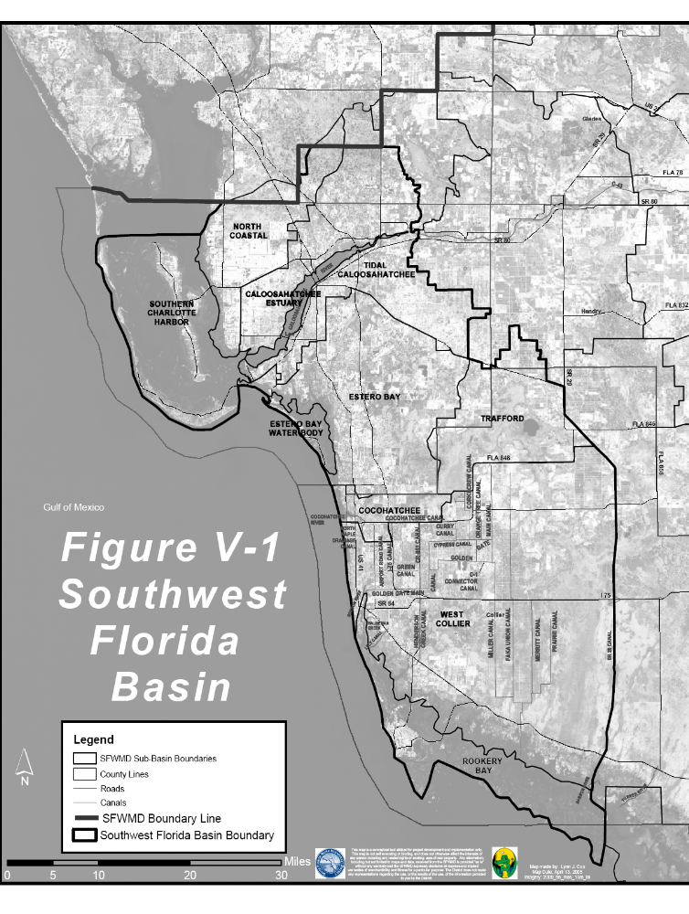
Appendix B: Relevant Internet Based Information Sites
In addition to the publications from the South Florida Water Management District

1.

http://www.dep.state.fl.us/water/stormwater/npdes/index.htm
http://www.dep.state.fl.us/water/nonpoint/erosion.htm

2.
 | 

http://www.dep.state.pa.us/dep/deputate/watermgt/wc/subjects/stormwatermanagement/default.htm

3.

http://www.georgiastormwater.com/
http://crd.dnr.state.ga.us/content/displaycontent.asp?txtDocument=969

4.

http://www.dem.ri.gov/pubs/regs/regs/water/ms4final.pdf

A Stormwater Design Manual Toolbox
5. “The Stormwater Manager's Resource Center”
http://www.stormwatercenter.net/

6.
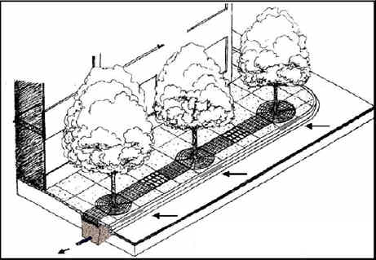
Low Impact Development Center
http://www.lid-stormwater.net/treebox/treeboxfilter_home.htm
http://www.lid-stormwater.net/bioretention/bio_benefits.htm

7.
 (Lee County, Georgia)
http://www.lee.ga.us/

8.
 City of Tampa
http://www.tampagov.net/dept_stormwater/index.asp
http://www.tampagov.net/dept_stormwater/files/SW_Private_Dev_Tech_Manual.pdf

9. Maryland Stormwater Management
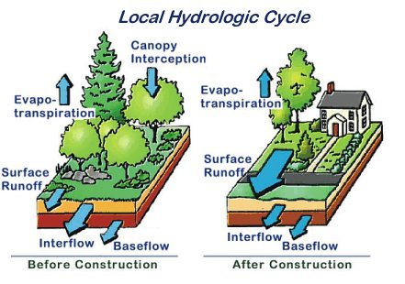

http://www.mde.state.md.us/Programs/WaterPrograms/SedimentandStormwater/home/index.asp
http://www.scdhec.gov/water/lid/pdf/lid_paper.pdf

10. Massachusetts Stormwater Programs
http://www.mass.gov/dep/water/laws/policies.htm#storm

11. Minnesota Stormwater Manual
http://www.pca.state.us/water/stormwater/stormwater-manual.htm!

12.

http://www.gcpa.org/pervious_concrete_pavement.htm

13.
 Atlanta, Ga.
http://www.coolcommunities.org/cool_pavements.htm

14.
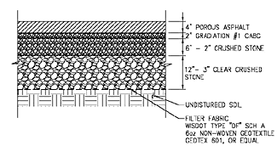
MSOE's Pervious Parking Lot
http://www.msoe.edu/ae/msev/projects/

15. International Conference on Aquatic Invasive Species
May 14-19, 2006
Key Biscayne, Florida
ww.icais.org
http://www.hcipub.com/events.asp

16.

http://www.erd.org/webdoc4.htm#top
http://www.stormwaterauthority.org/assets/115PGroundwater.pdf

17. “Virginia Polytechnic University Thesis”
http://scholar.lib.vt.edu/theses/available/etd-05302000-16250046/unrestricted/ThesisSBLFinal.PDF

18.

http://www.tentowns.org/10t/ordstrmw.htm

19. Stormwater Authority
http://www.stormwaterauthority.org/library/library.aspx?id=211

20. Villanova University
http://egrfaculty.villanova.edu/public/Civil_Environmental/WREE/VUSP_Web_Folder/TI_web_folder/GG-TI-Final_Report.pdf
http://www.bae.ncsu.edu/programs/extension/wqg/05rept319/pdf_files/PA-vill-05.pdf

21. Southwest Florida Water Management District
http://www.swfwmd.state.fl.us/documents/

22.

U.S. Geological Survey
http://pubs.er.usgs.gov/usgspubs/index.jsp?jboEventVo=PubResultView&view=basic&jboEvent=Search&pxfield_all=Stormwater&test=++Go++
http://pubs.usgs.gov/of/2004/1346/

23.

Stormwater Management Academy
http://www.stormwater.ucf.edu/

24.
. 
U.S. Environmental Protection Agency
http://www.bmpdatabase.org/
http://www.stormwatercenter.net/Library/STP-Pollutant-Removal-Database.pdf
http://www.epa.gov/ost/stormwater/
http://www.epa.gov/owow/watershed/

25.
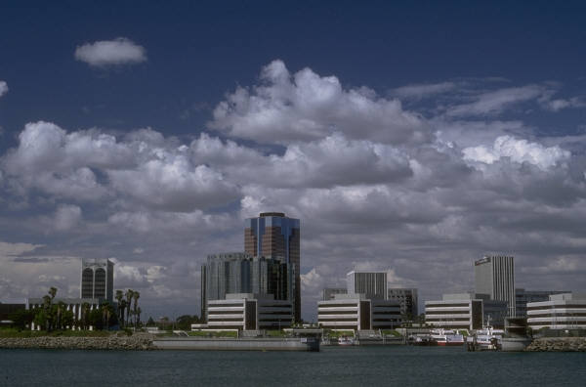
“An Internet Guide to Financing Stormwater Management.”
Indiana University-Purdue University Indianapolis (IUPUI)
http://stormwaterfinance.urbancenter.iupui.edu/

26.

http://www.mastep.net/project.cfm

27. Kara Construction. Stuart, Fl
http://www.perviouspavement.com/

28. Rinker Materials, Florida

http://www.landdevelopmenttoday.com/Article327.htm

29. Natural Resources Defense Council

http://www.nrdc.org/water/pollution/storm/chap12.asp

30. State of South Carolina
http://www.scdhec.gov/water/lid/

31. US Department of Housing and Urban Development

http://www.nahbrc.org/tertiaryR.asp?TrackID=&DocumentID=2007&CategoryID=1071
http://www.huduser.org/Publications/PDF/practLowImpctDevel.pdf

32. Puget sound



http://www.psat.wa.gov/Programs/LID.htm
http://www.psat.wa.gov/Publications/LID_tech_manual05/LID_manual2005.pdf

Numbers 33-41 indicate training or education workshops.

33. http://www.awra.org/proceedings/gis32/xue/index.html (AWRA SYMPOSIUM)

34. http://dels.nas.edu/wstb/ (Water Science and Technology Board)

35. http://www.florida-stormwater.org/newsletters/archives/default.asp (Florida Stormwater Association conferences twice per year)

36. http://www.wgba.org/artman/publish/cat_index_25.shtml [Wisconsin Green Building Alliance's (WGBA)]

37. http://ecocomplex.rutgers.edu/news_events.php (Stormwater Symposiums)

38. http://www.dec.state.ny.us/website/dow/calendar.html (Calendar of Events)
39. http://www.greenroofs.com/upcoming_events.htm ( Green roofs for healthy cities)

40. http://www.stormcon.com/sc.html (trade workshops)

41. http://www.stormwater.ucf.edu (research and application workshops)

42.
http://www.fhwa.dot.gov/environment/ultraurb/3fs2.ht
http://www.fhwa.dot.gov/engineering/hydraulics/conferences/2004ntlhyd/04hyag.cfm

43.


http://www.nrmca.org/certifications/pervious/
http://www.perviousconcrete.info/index.htm

44.
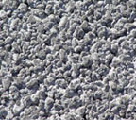

http://magruderconstruction.com/Pervious.html

